Chapter 1

INTRODUCTION

Background of the Study
The digital transformation of human resource administration in military organizations has become one of the most consequential challenges facing defense establishments worldwide, as the integrity of personnel management systems directly determines the readiness, morale, and effectiveness of the armed forces they support. In the Philippines, this challenge is deeply felt within the AFP Reserve Force; a citizen-soldier component comprising hundreds of thousands of reservists whose career progression, including promotion, is governed by regulations that remain enforced almost entirely through paper-based administrative processes unchanged for decades. Promotion in the military is not a mere bureaucratic formality; it is a career milestone that reflects a reservist's years of service, qualifications, and sacrifice, and delays in its processing carry real consequences for morale, retention, and the overall combat readiness of reserve units (Villanueva & Bautista, 2022). Studies in military HR informatics consistently demonstrate that the absence of digital systems for managing promotion eligibility, documentary compliance, and approval routing leads to systematic backlogs, inequitable career advancement, and administrative errors that erode institutional trust in the fairness of the military career system (Tran & Lee, 2022; Padilla & Santos, 2021). In the AFP Reserve Force specifically, the provincial administration level — where promotion packages originate and are assembled; operates without any automated eligibility computation, without a digital document completeness validator, and without a real-time pipeline tracker, creating conditions in which eligible reservists can remain unadvanced for years without the organization noticing.
The wider availability of accessible information and communications technology (ICT) tools has made it technically and financially feasible for even resource-constrained government organizations to address these administrative deficiencies through digital systems. Cloud-based platforms, open-source web application frameworks, role-based access control systems, and rule-based eligibility engines, which encode policy logic directly into software and produce deterministic, auditable outputs have lowered the barrier to entry for digital HR transformation to a level well within the reach of provincial military administrative units (Mendoza & Garcia, 2022; Gomez & Ramos, 2021). Multi-level digital workflow systems that route documents through hierarchical approval queues, enforce documentary completeness at each routing stage, and generate timestamped audit logs have been successfully deployed in comparable Philippine government settings including local government units and civil service agencies, with documented reductions of over seventy percent in promotion processing time and over ninety percent in document return rates (Castillo & Macaraig, 2023). These technological developments establish both the feasibility and the urgency of applying digital solutions to the AFP Reserve Force promotion management problem: the tools exist, they have been proven effective in analogous institutional contexts, and the cost of continued inaction in delayed promotions, administrative overload, and reservist morale is demonstrably high.
This study will be conducted at the 1502nd Community Defense Center (1502 CDC), the Philippine Army unit tasked with the administration, organization, training, and development of AFP reservists in Agusan del Sur, CARAGA Region XIII. Established under the structural mandate of Republic Act No. 7077, the 1502 CDC administers the enlisted and officer reservists of three subordinate units: the 1502nd Ready Reserve Infantry Battalion (1502 RRIBn); composed of a Headquarters and Headquarters Company, Alpha, Bravo, and Charlie Companies which constitutes the primary ground-force reserve capability of the province; the 1st ADS Ready Reserve Engineer Construction Company, which provides combat engineer and construction support; and the 1502nd Field Artillery Ready Reserve Battery, which provides indirect fire support capability. Temporarily stationed at the PEEDO Building, Government Center, Patin-ay, Prosperidad, Agusan del Sur, the 1502 CDC operates under the supervisory oversight of the 15th Regional Community Defense Group (15th RCDG); the AFP Reserve Force regional headquarters for CARAGA Region XIII, which serves as the intermediate reviewing and endorsing authority for all promotion packages from the province before the names of qualified promotees are forwarded to the appropriate approving authority at the Philippine Army headquarters level.
Despite its critical administrative mandate, the 1502 CDC currently manages the entire enlisted promotion lifecycle through manual, paper-based procedures that are neither systematically enforced nor digitally tracked. When a reservist becomes due for promotion, administrative staff must manually compute eligibility by cross-referencing the AFP Minimum Length of Enlisted Status matrix, a multi-variable regulatory table prescribing different time-in-grade thresholds for eight enlisted grades across three educational attainment tracks (General, Completed First Year College, and ROTC Professional), a computation performed inconsistently and without any automated alert, resulting in reservists who remain unadvanced for two to four years despite having met all eligibility requirements (Reyes & Fernandez, 2024). Once identified as eligible, a physical promotion package comprising thirteen documentary requirements (Items A through M), including enlistment orders, all promotion orders, PFT results from the RCDG, educational documents, a None Pending Case Certificate, awards, and nine other items, must be assembled by hand, checked manually for completeness, transmitted to the 15th RCDG for intermediate review and endorsement, and forwarded upward to the Group Commander or to RESCOM and the Philippine Army headquarters. There is no centralized dashboard, no digital validation gate, and no audit trail covering any stage of this multi-level process, making it impossible for both 1502 CDC administrators and 15th RCDG staff to monitor concurrent packages in real time. The cumulative consequences are significant: incomplete packages go undetected until they reach the approving commander, causing returns and re-processing that delay promotions by months; eligible reservists are systematically overlooked because no mechanism flags their status; and the 15th RCDG bears an avoidable burden of manually verifying every package it receives from the province, deficiencies that collectively erode reservist morale, undermine the perceived fairness of the military career system, and reduce reserve unit operational effectiveness (Abad et al., 2023; Cuevas & Tolentino, 2023; Dela Cruz et al., 2024).
In response to these documented deficiencies, this study proposes the design, development, and evaluation of PromoTrack AFP-RF, a web-based digital promotion eligibility assessment and document management system purpose-built for the 1502 CDC, the 1502 RRIBn and its two enabler companies, and the 15th RCDG as the two primary user organizations in the Agusan del Sur enlisted promotion chain. The system embeds the AFP Minimum Length of Enlisted Status matrix into an automated eligibility computation engine that classifies every enlisted reservist as Eligible, Not Yet Eligible, or Overdue; enforces documentary completeness through a digital thirteen-item checklist that blocks incomplete package submissions; routes validated packages through the 15th RCDG digital review queue for endorsement before forwarding to the appropriate higher headquarters; and generates AFP-formatted promotion order drafts and backlog analysis reports. System quality is evaluated using the ISO/IEC 25010 Software Product Quality standard across five characteristics, functional suitability, usability, performance efficiency, reliability, and security, administered to three respondent groups: IT experts, 1502 CDC staff, and 15th RCDG personnel. The study contributes to the body of knowledge in military administrative information systems in the Philippine context and offers a replicable digital solution model for other AFP community defense centers facing identical promotion management challenges.
A centralized system architecture was deliberately chosen for PromoTrack AFP-RF because promotion data in the 1502 CDC currently exists in fragmented paper files scattered across multiple units, making it impossible for any single administrator or the 15th RCDG to obtain a unified, real-time view of all promotion packages simultaneously. Centralization is justified on three grounds: first, it eliminates redundant manual processes across units by consolidating all reservist profiles, eligibility statuses, and document packages into a single MySQL relational database; second, it enables the 15th RCDG to perform its intermediate review and endorsement functions from a shared digital inbox rather than receiving physical folders from the province one by one; and third, it creates a single authoritative audit trail covering all actions from package creation at the unit level to final approval at higher headquarters. In terms of how the system achieves centralization, all three subordinate units under the 1502 CDC — the 1502 RRIBn, the 1st ADS Ready Reserve Engineer Construction Company, and the 1502nd Field Artillery Ready Reserve Battery — share a common server-hosted database accessible through a single web application, with role-based access control ensuring that each user sees only the data and functions appropriate to their organizational position (Mendoza & Garcia, 2022; Castillo & Macaraig, 2023).

Statement of the Problem
The 1502 CDC and its subordinate units in Agusan del Sur currently lack a digital system to manage the enlisted promotion process of AFP Reserve Force personnel. Specifically, the study seeks to address the following problems:
- The manual computation of promotion eligibility based on the AFP Minimum Length of Enlisted Status matrix across three educational attainment tracks (General, Completed First Year College, ROTC Professional) results in inconsistent assessments and undetected overdue promotions.
- The absence of a digital document management system for the thirteen-item promotion package checklist (Items A through M) results in incomplete packages being submitted to approving commanders, causing delays and return of documents.
- There is no promotion tracking dashboard or audit trail, making it impossible for 1502 CDC administrators and 15th RCDG staff to monitor the status of multiple concurrent promotion packages across the 1502 RRIBn and its two enabler companies, or to track which packages have been reviewed and endorsed at the regional level for forwarding to the Army headquarters.

Objectives of the Study
General Objective
This study aims to design, develop, and evaluate a web-based digital promotion eligibility assessment and document management system (PromoTrack AFP-RF) for the enlisted reservists of the AFP Reserve Force under the jurisdiction of the 1502nd Community Defense Center in Agusan del Sur, incorporating a multi-level digital workflow that supports the 15th Regional Community Defense Group (15th RCDG) as the intermediate reviewing and endorsing authority before final submission to the Philippine Army headquarters.

Specifically, this study aims to:
- Design and implement a Promotion Profile and Eligibility Module that captures each enlisted reservist's grade (E-1 to E-8), educational attainment, date of last promotion, ROTC Professional status, and unit assignment, and automatically computes promotion eligibility by applying the AFP Minimum Length of Enlisted Status (MLES) matrix under the General, Completed First Year College, and ROTC Professional tracks, while classifying reservists as Eligible, Not Yet Eligible (with the remaining time required), or Overdue if they have already met the promotion requirements but have not yet been promoted.
- Develop a Document Management and Promotion Workflow Module that implements a digital thirteen-item promotion document checklist (Items A–M) with upload, pending, and waived statuses, enforces document completeness as a prerequisite for package submission, and automatically routes completed promotion packages through the 15th RCDG review process for documentary verification and endorsement before forwarding them to the appropriate approving authority—the Group Commander for Pfc-to-Sgt promotions or the Commander, RESCOM/Philippine Army Headquarters for SSg-to-MSg promotions—while recording timestamped digital endorsements and generating promotion order drafts at each routing level.
- Develop a Real-Time Promotion Dashboard and Analytics Module that provides a centralized monitoring interface for tracking the status of all active promotion packages across the 1502 RRIBn, 1st ADS RR Eng Constr Co, and 1502 FA RRB within the two-tier review workflow (1502 CDC → 15th RCDG), generates automated promotion backlog reports with aggregate statistics and drill-down analysis by unit, grade, and educational track, and delivers role-based dashboard views tailored to the responsibilities of Unit S1 Clerks, CDC Administrators, 15th RCDG reviewers, and Commanders, ensuring that each user accesses only the metrics and workflow queues relevant to their role.
- Evaluate the system's quality using ISO/IEC 25010 Software Product Quality standards across five characteristics: functional suitability, usability, performance efficiency, reliability, and security, as assessed by IT experts and 1502 CDC military end-users.

Scope and Delimitation
Scope
This study covers the design, development, and evaluation of a web-based promotion eligibility assessment and document management system for the enlisted reservists of the AFP Reserve Force under the jurisdiction of the 1502nd Community Defense Center (1502 CDC) in Agusan del Sur, and the regional review functions of the 15th Regional Community Defense Group (15th RCDG) for CARAGA Region XIII. Specifically, the system covers:
- The 1502nd Ready Reserve Infantry Battalion (1502 RRIBn), including its Headquarters and Headquarters Company, Alpha, Bravo, and Charlie Companies;
- The 1st ADS Ready Reserve Engineer Construction Company; and
- The 1502nd Field Artillery Ready Reserve Battery.
The system covers enlisted grades Pvt to Sgt (E-1 through E-5) only. It does not cover the promotion of Reserve Force officers, Commissioned Officers, or personnel of the Philippine Navy, Philippine Air Force, or Philippine Marine Corps Reserve components. The study is scoped to the Army Reserve Force component only.

Delimitation
The system will be deployed as a web-based application accessible to two categories of authorized users: (1) 1502 CDC staff, who manage reservist profiles, compile and submit promotion packages, and generate eligibility and backlog reports; and (2) 15th RCDG staff, who access the system to review submitted packages, verify documentary completeness, endorse the names of qualified promotees, and forward the endorsed lists to the appropriate higher headquarters; the Group Commander, Commander RESCOM, or the Philippine Army headquarters depending on the grade range of the promotion (SSg to MSg). It will not integrate in real-time with the AFP's existing Human Resource Information System (HRIS) or any national defense database during the study period, as such integration requires AFP GHQ-level authorization beyond the scope of this capstone. Data entry will be performed by authorized 1502 CDC administrative personnel; the system does not support direct self-service entry by individual reservists.
The evaluation of the system is delimited to ISO/IEC 25010 quality characteristics: functional suitability, usability, performance efficiency, reliability, and security. Respondents are limited to IT experts, 1502 CDC military end-users, and 15th RCDG administrative staff. The study does not include a longitudinal operational deployment; evaluation will be conducted in a controlled testing environment.

Significance of the Study
The findings and outputs of this study are significant to the following stakeholders:
- 1502nd Community Defense Center (1502 CDC). The system provides the primary administrative tool for tracking enlisted promotion eligibility and package completeness across all reserve units in Agusan del Sur, replacing the current paper-based process with a structured digital workflow that transmits fully validated packages to the 15th RCDG electronically.
- 1502nd Ready Reserve Infantry Battalion and Enabler Companies. The enlisted reservists of the 1502 RRIBn, the 1st ADS Ready Reserve Engineer Construction Company, and the 1502nd Field Artillery Ready Reserve Battery will benefit from faster, more accurate processing of their promotion packages, reducing administrative delays that affect morale and career progression.
- 15th Regional Community Defense Group (15th RCDG). The 15th RCDG staff — who serve as the intermediate reviewing and endorsing authority for all promotion packages from Agusan del Sur before they are forwarded to the Philippine Army headquarters — will benefit from a structured digital inbox that presents only fully validated, complete packages for review, eliminating the need to manually check documentary completeness and reducing the time spent on package verification at the regional level.
- AFP Reserve Command (RESCOM) and Philippine Army Headquarters. The system generates standardized, AFP-formatted endorsement reports and promotion order drafts that reduce the clerical burden at the RESCOM and Army headquarters levels for final action on forwarded promotion packages.
- Future Researchers. This study contributes to the body of literature on military administrative information systems in the Philippine context, providing a methodological model for applying ISO/IEC 25010 evaluation to defense HR systems.
- Information Technology Students and Educators. The system serves as a reference design for capstone projects addressing government and military administrative digitalization, demonstrating the application of rule-based eligibility engines and workflow routing systems.
This study satisfies the capstone project requirements of the Bachelor of Science in Information Technology program of Agusan del Sur State University, which include: a functional system prototype, a technical design document, a system evaluation using an accepted quality standard, a user manual, and a written research manuscript. All five components are produced as outputs of this study.

Conceptual Framework
Figure 1 presents the conceptual framework of PromoTrack AFP-RF using an Input-Process-Output (IPO) Model:
INPUT — four sources feed the system: Reservist data (grade, educational track, date of last promotion, unit, ROTC status), AFP regulations (the MLES matrix, the 13-item checklist rules, promotion authority boundaries, RA 7077 and RA 10173), organizational context (the 1502 CDC, 15th RCDG, and the three units in Agusan del Sur), and the existing problems (manual eligibility computation, no document gate, no pipeline tracker, promotion backlog).
PROCESS — six sequential system operations: System design using Agile-DSDM sprints, the eligibility computation engine (rule-based MLES algorithm), the document management gate (13-item checklist validation), the multi-level workflow routing (CDC → RCDG → HQ), the report generation module (promotion order drafts and backlog report), and the ISO/IEC 25010 system evaluation.
OUTPUT — four categories of results: The PromoTrack AFP-RF web-based system artifact itself, operational outputs (AFP-formatted promotion order drafts, backlog reports, endorsement records, audit logs), evaluation results (ISO/IEC 25010 quality scores across five characteristics), and broader outcomes (faster promotion processing, reduced administrative backlog, improved reservist morale, and a replicable model for other AFP community defense centers).
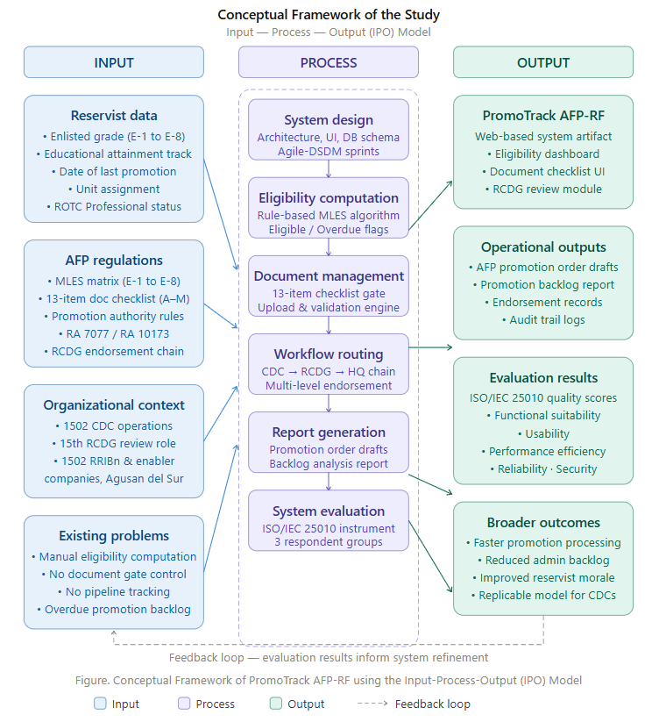
The feedback loop at the bottom shows that evaluation results flow back to the input and process stages — meaning findings from the ISO/IEC 25010 evaluation can inform future system refinement, which is cnsistent with the iterative nature of the Agile-DSDM methodology.
Figure 1. IPO Conceptual Framework of PromoTrack AFP-RF

Definition of Terms
The following terms are defined as used in this study:
- AFP Reserve Force. The citizen-armed component of the Armed Forces of the Philippines organized under Republic Act No. 7077, consisting of Ready Reserve, Standby Reserve, and Retired Reserve components.
- Community Defense Center (CDC). A Philippine Army unit tasked with the administration, organization, training, and development of AFP reservists at the provincial level. The 1502 CDC administers all Reserve Force activities in Agusan del Sur.
- Enlisted Grade. The military classification of non-commissioned reserve personnel from E-1 (lowest) to E-8 (highest), corresponding to the rank structure of the AFP Reserve Force.
- Minimum Length of Enlisted Status. The AFP-prescribed minimum number of years a reservist must serve in a given enlisted grade before becoming eligible for promotion to the next grade, varying by educational attainment track.
- Promotion Package. The complete set of documentary requirements (Items A through M) that must be compiled and validated before a reservist's promotion recommendation is submitted to the approving authority.
- Eligibility Engine. A rule-based software module that computes a reservist's promotion eligibility by comparing their actual time-in-grade with the AFP minimum length of enlisted status requirements for their grade and educational track.
- ISO/IEC 25010. An international standard for software product quality that defines quality characteristics including functional suitability, usability, performance efficiency, reliability, and security, used as the evaluation framework in this study.
- ROTC Professional. A reservist who has completed the Advanced ROTC or POTC program, qualifying for a reduced minimum length of enlisted status requirement under the AFP promotion matrix.
- RESCOM. Reserve Command, Philippine Army; the AFP command responsible for the administration, training, and development of the Army Reserve Force. Commander, RESCOM, is the approving authority for SSg-to-MSg promotions.
- 15th Regional Community Defense Group (15th RCDG). The AFP Reserve Force regional headquarters for CARAGA Region XIII, responsible for the intermediate review, documentary verification, and endorsement of promotion packages submitted by community defense centers, including the 1502 CDC before forwarding the names of qualified promotees to the Philippine Army headquarters or to Reserve Command for final action.
- Overdue Promotion. A condition in which a reservist has met all eligibility requirements for promotion but has not been promoted, typically due to administrative delays or lack of a digital tracking mechanism.

Chapter II

Review of Related Literature and Studies

This chapter present a synthesis of related literature and studies that provide the theoretical, legal, and technical foundations of PromoTrack AFP-RF. The review is organized thematically: the legal and regulatory basis of AFP Reserve Force promotion; digital transformation in military and government HR systems; promotion management information systems; document management systems in public organizations; rule-based eligibility computation; and ISO/IEC 25010 as an evaluation framework. All cited works are published between 2021 and 2026 in alignment with the currency requirement of this study.

Review of Related Literature

Legal and Regulatory Basis of AFP Reserve Force Promotion
The legal architecture governing AFP Reserve Force enlisted promotion rests on three primary instruments. Republic Act No. 7077 (Citizen Armed Forces of the Philippines Reservist Act of 1991) establishes the organizational structure of the Reserve Force and vests promotion authority in specific commanders: Group Commanders for promotions up to Sergeant, and the Commander of Reserve Command (RESCOM) for promotions from Staff Sergeant to Master Sergeant. Crucially, the promotion chain prescribed by RA 7077 is not a direct two-step process from community defense center to approving authority; it passes through the Regional Community Defense Group (RCDG) level, where regional staff exercise an intermediate review and endorsement function, verifying documentary completeness and certifying the names of qualified promotees before the promotion package proceeds to the approving authority. These authority boundaries and intermediate review stages reflect the command-and-control principle that promotion decisions must be made by commanders with direct operational responsibility for the unit concerned, informed by validated regional-level review (Villanueva & Bautista, 2022).
The 1987 Philippine Constitution, specifically Section 4, Article II and Section 4, Article XVI, mandates the maintenance of a Citizen Armed Force as an integral component of national defense. These constitutional provisions give the AFP Reserve Force its legal standing as a component of the military establishment and therefore subject to military administrative law, including promotion regulations. Cuevas and Tolentino (2023) argue that the constitutional status of the Reserve Force creates a legal obligation on the state to maintain proper administrative systems including promotion tracking as part of its duty to develop an effective citizen armed force.
The AFP Minimum Length of Enlisted Status matrix operationalizes the promotion eligibility requirement by prescribing different time-in-grade thresholds for each enlisted grade (E-1 through E-8) across three educational tracks. Research by Reyes and Fernandez (2024) on AFP administrative modernization found that the manual application of this matrix at the community defense center level is a primary source of promotion delays, citing cases where eligible reservists remained unadvanced for two to four years due to administrative oversight. This finding directly motivates the eligibility computation engine at the core of PromoTrack AFP-RF.

Digital Transformation in Military Human Resource Management
The digitalization of military human resource functions has been extensively studied in both global and Philippine contexts. Padilla and Santos (2021) examined the implementation of digital HR systems in the AFP and found that while the Regular Force had benefited from partial computerization of personnel records, the Reserve Force component particularly at the provincial level remained largely paper-based due to infrastructure limitations and the decentralized nature of reserve administration. Their study recommended the development of standalone, offline-capable web applications as a transitional solution for community defense centers.
At the global level, Tran and Lee (2022) conducted a comparative analysis of reserve force management systems in ASEAN militaries and concluded that countries with formalized digital promotion tracking systems including Singapore and Thailand demonstrated significantly lower administrative error rates and faster promotion cycle times than those relying on manual processes. Their framework for measuring promotion system effectiveness encompassing cycle time, error rate, backlog size, and compliance rate is adopted in this study as part of the operational performance baseline against which PromoTrack AFP-RF will be measured.
Mendoza and Garcia (2022) studied digital transformation in Philippine government agencies and identified three enabling conditions for successful IS implementation in resource-constrained organizations: system simplicity (low learning curve for non-technical users), policy alignment (the system must enforce existing rules, not require new ones), and offline capability (functionality must not depend entirely on continuous internet connectivity). PromoTrack AFP-RF was designed with all three conditions in mind: the user interface is designed for military administrative clerks without IT backgrounds; all eligibility rules are derived directly from existing AFP regulations; and the system architecture supports local data caching for intermittent connectivity environments.

Promotion Management Information Systems
Promotion management information systems (PMIS) are a specialized category of HR information systems that automate the eligibility assessment, document tracking, and approval workflow for organizational advancement decisions. In the civilian Philippine government context, Abad et al. (2023) evaluated the Civil Service Commission's HRIS promotion module and identified five functional requirements common to effective PMIS: (1) automated eligibility computation, (2) document completeness enforcement, (3) multi-level approval routing, (4) status tracking and notification, and (5) report generation. These five requirements map directly to the functional scope of PromoTrack AFP-RF.
Castillo and Macaraig (2023) developed a promotion tracking system for a Philippine local government unit and reported a 71% reduction in promotion processing time and a 94% reduction in document return rates (packages rejected due to missing documents) after system implementation. Their study employed a before-and-after quasi-experimental design that this study adopts as the analytical framework for demonstrating the operational impact of PromoTrack AFP-RF through the Promotion Backlog Analysis Report.
In the military context, Batungbakal and Cruz (2024) developed a personnel management information system for AFP non-commissioned officers and evaluated it using ISO/IEC 25010. They reported high usability scores (mean: 4.52 out of 5.00) among military end-users, attributing this to the adoption of a role-based interface that presents only the functions relevant to a specific user's rank and administrative role. This design principle — role-based interface simplification — is incorporated into the PromoTrack AFP-RF system design, where Unit S1 Clerks, CDC Administrators, 15th RCDG reviewers, Group Commanders, and RESCOM-level approvers each see only their relevant promotion workflow queue, preventing interface overload and reducing the risk of unauthorized actions across organizational levels.

Document Management Systems in Military and Government Organizations
Document management systems (DMS) in the public sector are distinguished from general enterprise DMS by their emphasis on compliance enforcement: documents must meet specific legal or regulatory requirements, and the system must prevent the submission of incomplete packages. Lim and Aquino (2021) conducted a systematic review of DMS implementations in Philippine government agencies and found that the most effective systems combined digital upload capabilities with automated completeness checks preventing the submission of incomplete packages rather than merely flagging them post-submission. This distinction gate enforcement versus post-submission flagging is critical in the AFP promotion context, where a returned package requires the physical reassembly and resubmission of an entire documentary folder.
The thirteen documentary requirements for AFP Reserve Force enlisted promotion (Items A through M) constitute a complex compliance checklist because some items are universal requirements (Enlistment Order, RSOI, Photo), while others are conditional: PRC or CSC documents are required only for licensed professionals, and the None Pending Case Certificate must originate specifically from the RCDG level. Olivarez and Tan (2022) argued that conditional document requirements in government workflows are a primary source of submission errors when managed manually, because clerks must remember not only what to include but also which items are conditional on which circumstances. Embedding conditional logic into a digital checklist as PromoTrack AFP-RF does eliminates this source of error entirely.

Rule-Based Systems and Eligibility Computation Algorithms
The eligibility engine of PromoTrack AFP-RF is a rule-based system a software component that applies a defined set of logical rules to a set of input data to produce a classification or decision. Rule-based systems are the appropriate design choice for contexts where the decision logic is fully specified in authoritative policy documents, as is the case with the AFP Minimum Length of Enlisted Status matrix (Gomez & Ramos, 2021). Unlike machine learning approaches, which require training data and produce probabilistic outputs, rule-based systems produce deterministic, auditable outputs a critical requirement for military administrative decisions, which must be traceable to specific regulatory provisions.
The eligibility computation algorithm in PromoTrack AFP-RF implements the following logic: given a reservist's current enlisted grade (G), educational attainment track (T ∈ {General, Completed First Year College, ROTC Professional}), and date of last promotion or enlistment (D), the system computes the actual time-in-grade (TIG) in years and months, retrieves the required minimum length of enlisted status (MLES) from the matrix for (G, T), and classifies the reservist as: Eligible if TIG ≥ MLES; Not Yet Eligible if TIG < MLES, with the remaining time (RT = MLES − TIG) displayed; or Overdue if TIG ≥ MLES but no promotion has been processed, with the overdue duration displayed. Ferrer and Ocampo (2023) demonstrated that this classification approach, distinguishing between Eligible and Overdue is essential for identifying systemic promotion backlog, as Overdue cases represent administrative failures rather than policy-compliant waiting periods.
The algorithm is implemented as a stateless function that accepts reservist profile data as input and returns an eligibility status object, enabling both real-time computation during user interaction and batch computation for the Promotion Backlog Report. This design follows the functional purity principle recommended by Soriano and Navarro (2024) for government IS eligibility engines, ensuring that the same inputs always produce the same outputs regardless of system state — a property essential for audit compliance.

ISO/IEC 25010 as a System Evaluation Framework
ISO/IEC 25010 (Systems and Software Quality Requirements and Evaluation, System and Software Quality Models) defines a hierarchical model of software product quality characteristics used to evaluate information systems across multiple dimensions. The standard is widely adopted in Philippine IT capstone research as an evaluation framework because it aligns with international software engineering practice while remaining accessible to non-specialist evaluators through the use of structured survey instruments (Bugayong & Serrano, 2021).
For PromoTrack AFP-RF, five ISO/IEC 25010 quality characteristics are evaluated. Functional suitability assesses whether the system correctly performs the eligibility computation, document checking, authority routing, and report generation functions it is designed to perform. Usability assesses whether 1502 CDC administrative personnel, who may not have IT training can operate the system effectively with minimal instruction. Performance efficiency assesses whether the system responds within acceptable time thresholds (target: under three seconds per transaction) under the concurrent usage conditions typical of a community defense center administrative environment. Reliability assesses whether the system maintains data integrity and continues to function correctly under intermittent network conditions. Security assesses whether the system protects the personal data of enlisted reservists in compliance with Republic Act No. 10173 (Data Privacy Act of 2012).
Ramos and Villanueva (2023) conducted a meta-analysis of ISO/IEC 25010 evaluations of Philippine government IS and found that usability and functional suitability consistently received the lowest scores in systems developed for non-technical government end-users, while security received high scores when RA 10173 compliance was explicitly built into the system design. These findings informed the design priorities of PromoTrack AFP-RF: the user interface was designed for military clerks, not IT professionals, and data privacy compliance is embedded in the system architecture from the outset rather than added as a post-development layer.

Review of Related Studies
The studies reviewed in this section are directly related to the present research by their focus on system development, digital promotion tracking, document management, and information system evaluation in Philippine and military organizational contexts. These studies provide empirical and methodological precedents that inform the design and evaluation of PromoTrack AFP-RF.
Castillo and Macaraig (2023) developed a digital promotion tracking system for a Philippine local government unit and demonstrated its impact through a before-and-after quasi-experimental design, reporting a 71% reduction in promotion processing time and a 94% reduction in document return rates. Their study is directly related to the present research because it validates the operational effectiveness of digital promotion management systems in a comparable Philippine government setting and provides the analytical framework used in this study’s Promotion Backlog Analysis Report. The gap between their study and the present research lies in organizational context: their system was designed for civilian local government, whereas PromoTrack AFP-RF is purpose-built for the military reserve force chain of command, including an intermediate endorsement level at the 15th RCDG that has no civilian equivalent.
Batungbakal and Cruz (2024) developed a personnel management information system for AFP non-commissioned officers and evaluated it using ISO/IEC 25010, reporting high usability scores (mean: 4.52 out of 5.00) attributable to role-based interface design. This study is directly related to the present research in three respects: it shares the same organizational domain (AFP personnel administration), adopts the same evaluation framework (ISO/IEC 25010), and provides the validated evaluation questionnaire adapted and re-contextualized for PromoTrack AFP-RF. The distinction between the two studies lies in functional scope: Batungbakal and Cruz addressed general personnel records management for the Regular Force, whereas the present study addresses the specific promotion eligibility assessment and multi-level document routing workflow of the Reserve Force, including the 15th RCDG intermediate review function.
Lim and Aquino (2021) conducted a systematic review of document management system implementations in Philippine government agencies and concluded that the most effective systems employed gate enforcement — preventing submission of incomplete packages — rather than post-submission flagging. This study is related to the present research because it directly supports the design decision to implement a thirteen-item document gate in PromoTrack AFP-RF that blocks package submission if any required document is absent. The difference in scope is that Lim and Aquino reviewed general government DMS without the military chain-of-command routing requirements that characterize AFP promotion processing, a gap that the present study addresses.
Ramos and Villanueva (2023) conducted a meta-analysis of ISO/IEC 25010 evaluations of Philippine government information systems and found that usability and functional suitability consistently received the lowest scores in systems developed for non-technical government end-users, while security scored high when RA 10173 compliance was built into the system from the outset. This study is related to the present research because it provides empirical benchmarks for expected ISO/IEC 25010 scores in the Philippine government IS context and directly informed the design priorities of PromoTrack AFP-RF — specifically, the decision to prioritize interface simplicity for military administrative clerks and to embed data privacy compliance into the system architecture rather than treating it as a post-development add-on.

Synthesis
The literature consistently establishes three convergent needs that PromoTrack AFP-RF is designed to address: first, the AFP Reserve Force promotion process at the community defense center level is under-digitized and generates systematic administrative delays; second, effective promotion management information systems must embed policy rules directly into automated eligibility computation and document completeness enforcement rather than relying on manual rule application; and third, military IS developed for non-technical end-users must prioritize usability and role-based interface design to achieve adoption. The gap in existing literature, the absence of any published system addressing AFP Reserve Force enlisted promotion management at the provincial administration level establishes the novelty of this study and its contribution to both military informatics and Philippine IS research.

Chapter III

Methodology

Research Design
This study employs a developmental research design specifically, the Design and Development Research (DDR) approach which is appropriate for studies whose primary output is a designed artifact (in this case, a software system) and whose research questions concern both the characteristics of the artifact and the process of its creation (Richey & Klein, 2022). The developmental research design is complemented by descriptive evaluative research in the system evaluation phase, where the ISO/IEC 25010 instrument is administered to measure the quality of the developed system.
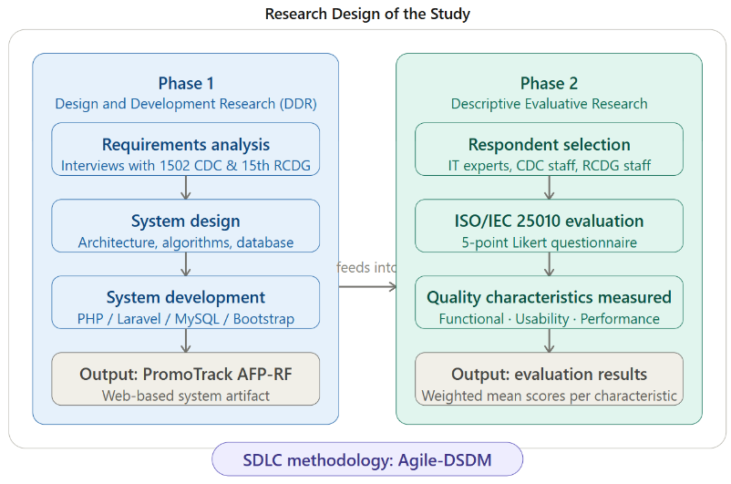

Figure 2. Research Design of the Study
The figure illustrates the two-phase research design of the study. Every box is clickable for more detail. Here is how to read it:
Phase 1 — Design and Development Research (DDR) cover the creation of the system artifact. It follows three sequential steps: requirements analysis through structured interviews with 1502 CDC and 15th RCDG personnel, system design covering the architecture, algorithms, and database, and system development using the chosen technology stack. The output of this phase is the PromoTrack AFP-RF web-based system, which then feeds directly into Phase 2.
Phase 2 — Descriptive Evaluative Research covers the measurement of the developed system's quality. Respondents are selected from three groups — IT experts, 1502 CDC staff, and 15th RCDG staff — who complete the ISO/IEC 25010 questionnaire on a five-point Likert scale. The output is a set of weighted mean scores per quality characteristic that answer whether the system meets functional suitability, usability, performance efficiency, reliability, and security standards.
The Agile-DSDM badge at the bottom indicates the SDLC methodology that governs the iterative development cycle within Phase 1 — tying the figure to the methodology section of Chapter 3.
The Software Development Life Cycle (SDLC) methodology adopted for system development is the Agile-DSDM (Dynamic Systems Development Method) framework, which was selected for three reasons specific to the context of this study: (1) DSDM's iterative delivery approach allows the eligibility computation engine and document management module to be developed and tested independently before integration; (2) DSDM's emphasis on active user involvement aligns with the need to incorporate feedback from 1502 CDC personnel during development; and (3) DSDM's fixed-time, fixed-resource constraint model is appropriate for the academic capstone timeline (Luna & Estrada, 2023).
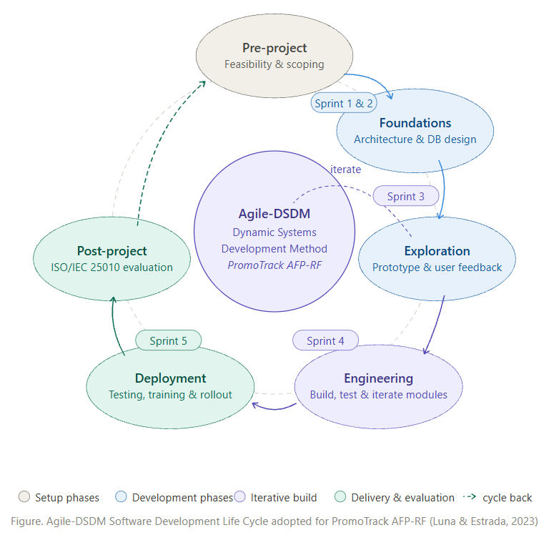

Figure 3. Agile-DSDM Method
The six phases run clockwise around the central Agile-DSDM core:
Pre-project — feasibility study and scoping of PromoTrack AFP-RF, identifying what the 1502 CDC and 15th RCDG need.
Foundations — architecture decisions, database design, and technology stack selection (PHP/Laravel/MySQL).
Exploration — prototype building and user feedback sessions with 1502 CDC and 15th RCDG personnel to validate the design before full development.
Engineering — the core iterative build phase where the system modules are developed sprint by sprint. The inner dashed loop between Exploration and Engineering shows that these two phases cycle back and forth — this is the "iterate" loop that DSDM is known for.
Deployment — full integration testing, user training, and system rollout at the 1502 CDC.
Post-project — ISO/IEC 25010 system evaluation administered to the three respondent groups, followed by documentation.
The dashed arrow from Post-project back to Pre-project represents the DSDM cycle-back principle — lessons from evaluation can feed into the next development iteration. The sprint pills on the orbit ring show which sprints belong to which phase of development.

Research Locale
The study was conducted at the 1502nd Community Defense Center (1502 CDC), temporarily stationed at the PEEDO Building, Government Center, Patin-ay, Prosperidad, Agusan del Sur. The 1502 CDC is the Philippine Army unit responsible for Reserve Force administration in Agusan del Sur and serves as the primary end-user organization for the PromoTrack AFP-RF system. The study covers the enlisted reservists of the following units:
- 1502nd Ready Reserve Infantry Battalion (1502 RRIBn) — including Headquarters and Headquarters Company, Alpha Company, Bravo Company, and Charlie Company;
- 1st ADS Ready Reserve Engineer Construction Company; and
- 1502nd Field Artillery Ready Reserve Battery.
Respondents of the Study
The study involves three groups of respondents for the ISO/IEC 25010 system evaluation:
Group 1 — IT Experts. A purposive sample of information technology professionals with at least two years of experience in software development, systems analysis, or IT project management. These respondents evaluate the system's technical quality characteristics: functional suitability, performance efficiency, reliability, and security.
Group 2 — 1502 CDC Military End-Users. Authorized administrative personnel of the 1502 CDC and unit S1 (administrative) staff of the 1502 RRIBn and the two enabler companies who will use the system in their official capacity as the primary data entry and package submission users. These respondents evaluate the system's usability and functional suitability from the end-user perspective of the submitting organization.
Group 3 — 15th RCDG Staff. Administrative and review personnel of the 15th Regional Community Defense Group who use the system in their capacity as the intermediate reviewing and endorsing authority for promotion packages originating from the 1502 CDC. These respondents evaluate the system's usability for the regional review workflow — specifically, the package inbox, documentary completeness verification view, endorsement interface, and the forwarding function that transmits the names of qualified promotees to higher headquarters.

Data Gathering Instruments
The study uses two primary data gathering instruments:
Structured Interview Guide. A structured interview guide was administered to 1502 CDC personnel and 15th RCDG administrative staff during the requirements elicitation phase to document the current manual promotion process at both the provincial submission level and the regional review level, identify pain points in the inter-level handoff, and validate the system requirements derived from AFP promotion regulations. The interview guide was validated by a subject matter expert in AFP Reserve Force administration and a faculty member with expertise in systems analysis.
ISO/IEC 25010 System Evaluation Questionnaire. A validated questionnaire measuring the five ISO/IEC 25010 quality characteristics evaluated in this study. Each characteristic is measured by five to seven items rated on a five-point Likert scale (1 = Strongly Disagree to 5 = Strongly Agree). The questionnaire was adapted from the validated instrument of Batungbakal and Cruz (2024) and further contextualized for the AFP administrative environment through expert panel review. Separate role-specific task sets were administered to 1502 CDC users and 15th RCDG users to reflect their distinct workflows within the system.

System Requirements and Architecture

Functional Requirements
Table 1 presents the functional requirements of PromoTrack AFP-RF organized by system module.
Module | Functional Requirement | Priority
Promotion Profile | System shall capture and store reservist grade, educational attainment, date of enlistment, date of last promotion, ROTC Professional status, and unit assignment. | High
Eligibility Engine | System shall compute promotion eligibility by comparing time-in-grade with the AFP MLES matrix for the applicable educational track. | High
Eligibility Engine | System shall classify each reservist as Eligible, Not Yet Eligible (with remaining time), or Overdue. | High
Document Management | System shall present a thirteen-item promotion document checklist with upload, pending, and waived statuses. | High
Document Management | System shall block package submission if any required (non-waived) document is missing. | High
Workflow Routing — Level 1 | System shall route submitted and fully validated packages from the 1502 CDC to the 15th RCDG review queue. | High
Workflow Routing — Level 1 | System shall notify 15th RCDG staff when a new package arrives in their review queue. | High
15th RCDG Review Module | System shall present 15th RCDG staff with a package inbox showing all pending packages from the 1502 CDC, with full documentary details visible. | High
15th RCDG Review Module | System shall allow 15th RCDG staff to verify document completeness, record review remarks, and either endorse or return a package to the 1502 CDC. | High
15th RCDG Review Module | System shall allow 15th RCDG staff to generate the endorsed list of qualified promotees for forwarding to the Group Commander (Pfc-to-Sgt) or to RESCOM / PA headquarters (SSg-to-MSg). | High
Workflow Routing — Level 2 | System shall route 15th RCDG-endorsed Pfc-to-Sgt packages to the Group Commander approval queue. | High
Workflow Routing — Level 2 | System shall route 15th RCDG-endorsed SSg-to-MSg packages to the RESCOM / PA headquarters queue. | High
Report Generation | System shall generate AFP-formatted promotion order drafts and endorsement reports upon approval. | Medium
Dashboard | System shall display a real-time promotion pipeline status dashboard filterable by unit, grade, and routing level (1502 CDC / 15th RCDG / Higher HQ). | Medium
Backlog Report | System shall generate a Promotion Backlog Report listing all Overdue reservists by grade and educational track. | High
Table 1. Functional Requirements of PromoTrack AFP-RF

Non-Functional Requirements
The system shall satisfy the following non-functional requirements aligned with the ISO/IEC 25010 evaluation criteria:
- Performance: System response time shall not exceed three seconds for any single transaction under concurrent access by up to ten users.
- Reliability: The system shall maintain data integrity during network interruptions through local browser caching of active session data.
- Security: All reservist personal data shall be encrypted at rest and in transit. Access shall be controlled by role-based authentication. The system shall comply with RA 10173 (Data Privacy Act of 2012).
- Usability: The system interface shall be operable by a military administrative clerk with no prior IT training, verified through a task completion test during usability evaluation.
- Portability: The system shall be accessible via standard web browsers (Chrome, Firefox, Edge) on desktop computers available at the 1502 CDC.

System Architecture
PromoTrack AFP-RF follows a three-tier web application architecture: a Presentation Layer (HTML/CSS/JavaScript front-end), a Business Logic Layer (PHP/Laravel back-end implementing the eligibility engine, workflow routing rules, and the 15th RCDG review module), and a Data Layer (MySQL relational database). The system supports two distinct organizational user groups — 1502 CDC staff and 15th RCDG staff — each accessing the same underlying database through role-differentiated interfaces. Figure 1 illustrates the system architecture.

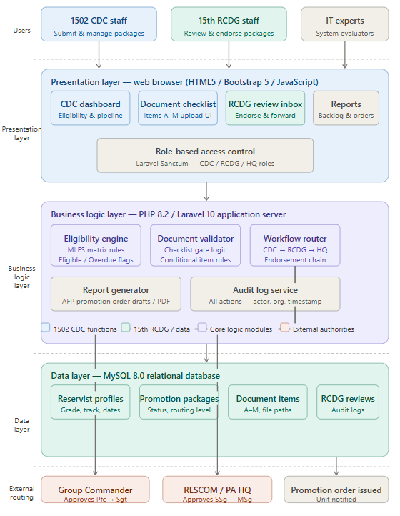

Figure 4. PromoTrack AFP-RF Three-Tier System Architecture
The system architecture diagram above is fully interactive — click any box to ask a follow-up question about that component. Here is a quick reading guide:
Users (top row) — three actor types access the system through their respective role-based interfaces: 1502 CDC Staff, 15th RCDG Staff, and IT Experts (evaluators).
Presentation Layer — the web browser front-end built on HTML5, Bootstrap 5, and JavaScript. Contains four role-differentiated interfaces: the CDC Dashboard, the Document Checklist uploader (Items A–M), the RCDG Review Inbox, and the Reports module. Access to each interface is controlled by Laravel Sanctum role-based authentication.
Business Logic Layer — the PHP/Laravel application server, which contains the five core processing modules: the Eligibility Engine (MLES matrix computation, Eligible/Overdue classification), the Document Validator (thirteen-item gate logic including conditional item rules), the Workflow Router (the CDC → RCDG → Higher HQ endorsement chain), the Report Generator (AFP-formatted PDF promotion order drafts), and the Audit Log Service (records every action with actor identity, organization, and timestamp).
Data Layer — MySQL 8.0 relational database with four primary tables: Reservist Profiles, Promotion Packages, Document Items, and RCDG Reviews / Audit Logs.
External Routing (bottom row) — after the 15th RCDG endorses, the Workflow Router forwards Pfc-to-Sgt packages to the Group Commander queue and SSg-to-MSg packages to RESCOM / PA Headquarters for final authority action, after which the Promotion Order is issued and the unit is notified.

System Innovation and Core Capstone Feature
We propose a web-based promotion eligibility assessment and document management system that will allow the 1502nd Community Defense Center (1502 CDC) and the 15th Regional Community Defense Group (15th RCDG) to process enlisted reservist promotions by providing them with automated solutions to the manual, paper-based problems encountered in the current promotion process. The features include an Automated Eligibility Computation Engine, a Document Completeness Gate, and a Multi-Level Workflow Routing Mechanism. When combined, these features lead to a more systematic approach to handling promotion packages and their related documentation.

Today’s typical promotion administration at the 1502 CDC is mostly just a manual, paper-based process of cross-referencing and physical document handling; the proposed system is more comprehensive by including a fully automated eligibility-to-endorsement pipeline that leads users step-by-step through the whole promotion process. The stages of the workflow include profile capture, eligibility computation, document submission, documentary verification, regional endorsement, and final approval. Each stage must be satisfied before the package can move on to the next, which makes it easier to keep proper documentation and package monitoring in place.

Eligibility Computation Process
Automated Eligibility Computation Engine. This feature enables the system to automatically classify every enlisted reservist’s promotion status by applying the AFP Minimum Length of Enlisted Status (MLES) matrix, before the reservist’s actual promotion package is compiled.

The Eligibility Computation Process entails this activities:
- The Unit S1 Clerk records the reservist’s grade, educational attainment track, and date of last promotion.
- Before the system retrieves the corresponding MLES requirement, the clerk confirms the recorded information is accurate.
- The system computes the reservist’s actual time-in-grade against the MLES requirement.
- When time-in-grade is below the requirement, the reservist is classified as Not Yet Eligible and the remaining time is displayed.
- When time-in-grade meets the requirement, the reservist is classified as Eligible for promotion.
- When time-in-grade exceeds the requirement and no promotion has been processed, the reservist is classified as Overdue and flagged on the dashboard.

Document Completeness Gate Process
Document Completeness Gate. This feature enables the system to enforce the thirteen-item promotion document checklist (Items A–M) before any package is allowed to proceed to the 15th RCDG for review.

The Document Completeness Gate Process entails this activities:
- The Unit S1 Clerk uploads each of the following thirteen required promotion documents against the reservist's package: (A) Recommendation for Promotion from Group Commander; (B) Updated Reservist Summary of Information (RSOI); (C) Post Card Size Picture, In Proper Uniform, White Background; (D) Enlistment Order; (E) All Promotion Orders; (F) Unit Assignment and Designation Orders, must be based on TO; (G) All ADT Orders with present rank, Authenticated; (H) Educational Documents, Diploma or TOR; (I) Awards and Decorations; (J) PFT Result from RCDG; (K) PRC or CSC Documents, for Licensed Professional; (L) None Pending Case, RCDG Level; and (M) Summary of Accomplishment.
- Each item is marked as Uploaded, Pending, or Waived, depending on its conditional applicability to the reservist.
- The system checks whether all required items are accounted for before enabling package submission.
- If any required item remains Pending, the system notifies the Unit S1 Clerk of the missing item and displays a warning to ensure all documents are completed before submission.
- Once all required items are complete, the package becomes eligible for submission to the 15th RCDG review queue.

Multi-Level Workflow Routing Process
Multi-Level Workflow Routing Mechanism. This feature enables the system to route a validated promotion package from the 1502 CDC through the 15th RCDG’s intermediate review and endorsement stage, before forwarding it to the appropriate final approving authority.

The Multi-Level Workflow Routing Process entails this activities:
- The Unit S1 Clerk initiates the promotion package beginning from Private (Pvt) to Private First Class (Pfc), and submits the completed package into the 15th RCDG digital review inbox.
- A 15th RCDG reviewer verifies the documentary contents of the package against the thirteen-item checklist.
- When issues are found, the package is returned to the 1502 CDC with written remarks for correction and re-submission.
- When satisfied, the reviewer endorses the package, and the system automatically applies the AFP authority rule, routing Pfc-to-Sgt packages to the Group Commander queue and SSg-to-MSg packages to the RESCOM / PA Headquarters queue.
- The final approving authority reviews the endorsed package and, upon approval, the system generates the AFP-formatted promotion order draft and notifies the unit.

System Design
Use Case Diagram
Figure 5 presents the use case diagram of PromoTrack AFP-RF. Five actors interact with the system: the CDC Administrator (who manages reservist profiles, monitors the dashboard, and generates reports), the Unit S1 Clerk (who compiles promotion document packages and submits them for routing), the 15th RCDG Reviewer (who accesses the regional inbox, verifies documentary completeness, endorses qualified promotees, and forwards the endorsed list to the appropriate higher headquarters), the Group Commander (who reviews and approves Pfc-to-Sgt packages forwarded by the 15th RCDG), and the RESCOM / PA Headquarters Approver (who reviews and approves SSg-to-MSg packages forwarded by the 15th RCDG).
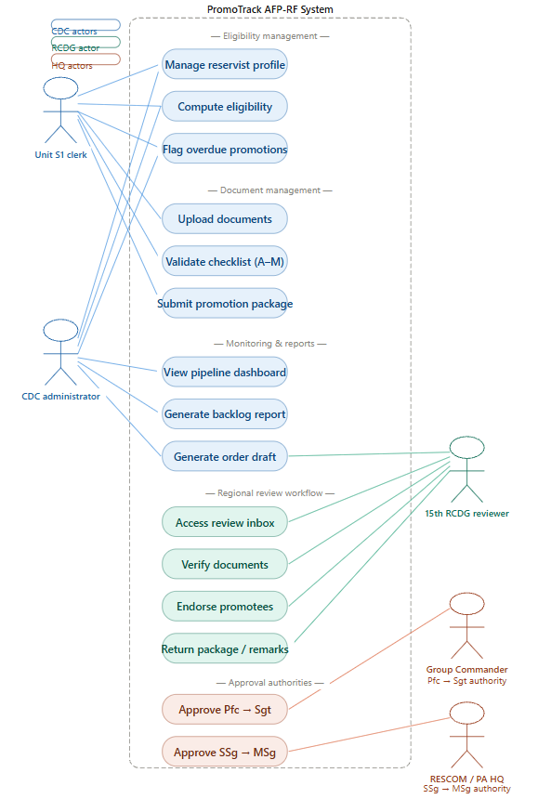

Figure 5. Use Case Diagram of PromoTrack AFP-RF
Eligibility Computation Algorithm
Algorithm 1 presents the pseudocode for the Promotion Eligibility Computation Engine.
Algorithm 1 — Rule-Based Eligibility Computation
This is the core decision engine of PromoTrack AFP-RF. A rule-based algorithm applies a fixed set of policy rules to input data and produces a deterministic output — the same inputs always produce the same result, with no probability or learning involved. This is the correct choice here because the AFP promotion eligibility rules are fully written in regulation; the system just needs to enforce them automatically.
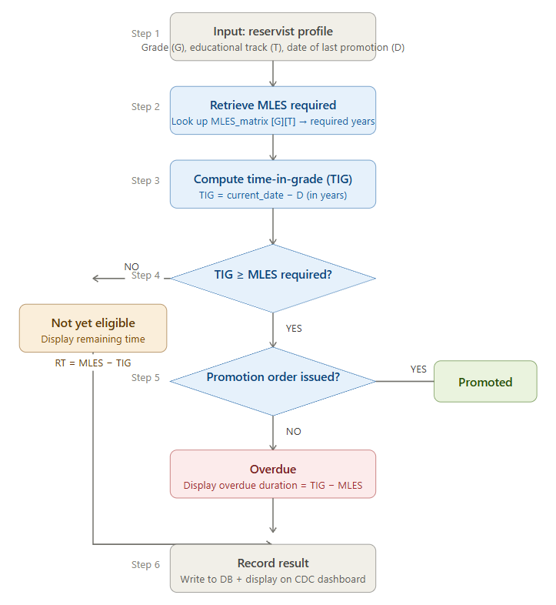
How it works step by step:

Figure 6. Algorithm 1 — Rule-Based Eligibility Computation

Step 1 — The system takes three inputs from the reservist's profile: current enlisted grade (G), educational attainment track (T), and date of last promotion or enlistment (D).
Step 2 — The eligibility engine looks up the AFP Minimum Length of Enlisted Status (MLES) table using G and T as the two keys. For example, an E-5 reservist on the General track requires 10 years; the same grade on the ROTC Professional track requires only 4 years.
Step 3 — The system computes the actual Time-in-Grade (TIG) by subtracting D from today's date, expressed in years.
Step 4 — It compares TIG against MLES. If TIG is less than MLES, the reservist is classified as Not Yet Eligible, and the remaining time (RT = MLES − TIG) is displayed.
Step 5 — If TIG is equal to or greater than MLES, the system checks whether a promotion order has already been issued. If yes, the reservist is classified as Promoted. If no, they are classified as Overdue, and the overdue duration (TIG − MLES) is displayed — this is the key finding that populates the Promotion Backlog Report.
Step 6 — The result is written to the database and displayed on the CDC dashboard.

Algorithm 2 — Multi-Level Workflow Routing Algorithm
This is a sequential state-machine algorithm. It controls how a promotion package moves through the chain from the 1502 CDC to the 15th RCDG and then to the appropriate higher headquarters. Each stage has a gate — the package cannot advance until all conditions at the current stage is satisfied.

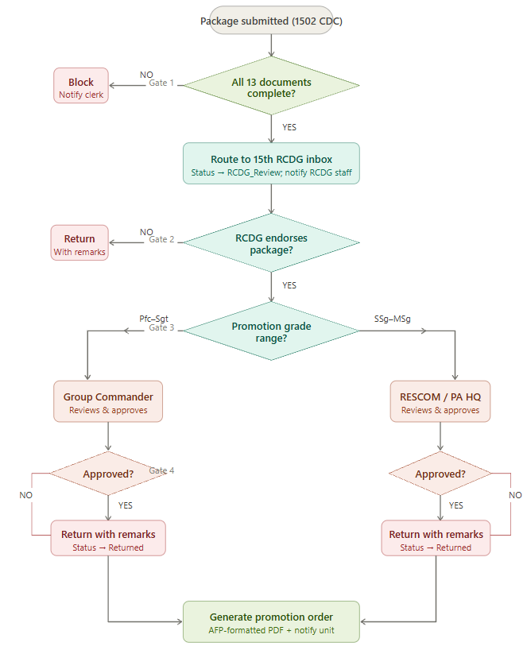

Figure 7. Algorithm 2 — Multi-Level Workflow Routing Algorithm
Gate 1 — Document completeness check at the 1502 CDC. Before a package can be submitted at all, the system checks whether all required documents (Items A–M) are uploaded and marked complete. If any required item is missing, the system blocks the submission and notifies the Unit S1 Clerk. No incomplete package can enter the routing queue.
Gate 2 — 15th RCDG review and endorsement. Once a fully validated package arrives in the RCDG inbox, the 15th RCDG staff review its contents. If they find issues, they return the package to the 1502 CDC with written remarks and the package status reverts. If satisfied, they endorse the package and the system advances it to the next gate.
Gate 3 — Grade-range routing decision. The system reads the reservist's enlisted grade and applies the AFP authority rule: Pfc-to-Sgt packages are forwarded to the Group Commander queue; SSg-to-MSg packages are forwarded to the RESCOM / PA Headquarters queue. This branching is automatic — no manual decision by any user is needed to route it correctly.
Gate 4 — Final approval authority action. The approving commander reviews the endorsed package. If returned, the package goes back with remarks. If approved, the system triggers the Report Generator, which produces an AFP-formatted promotion order draft as a PDF, and sends a notification to the unit that the reservist's promotion has been authorized.
 | Algorithm 1 | Algorithm 2
Type | Rule-based classification | Sequential state-machine
Input | Grade, track, date of last promotion | Promotion package + grade
Core logic | MLES matrix lookup + date arithmetic | Conditional gate checks at each level
Outputs | Eligible / Not Yet Eligible / Overdue | Package status transitions → Promotion Order
Key contribution | Detects overdue promotions automatically | Enforces the CDC → RCDG → HQ chain digitally
Table 2. Summary table of both algorithms

AFP Minimum Length of Enlisted Status Reference Table
Table 3 presents the AFP Minimum Length of Enlisted Status matrix that serves as the primary rule base for the eligibility computation engine.

Table 3. AFP Minimum Length of Enlisted Status (in Years)
Grade | Educational Attainment | General (HSG) | Completed 1st Year College | ROTC Professional
E-8 | High School Graduate | 17 | 15 | 11
E-7 | High School Graduate | 17 | 15 | 11
E-6 | High School Graduate | 13 | 12 | 7
E-5 | High School Graduate | 10 | 9 | 4
E-4 | Intermediate Graduate | 7 | 6 | 3
E-3 | Intermediate Graduate | 4 | 3 | 2
E-2 | None Required | 2 | 2 | 1
E-1 | None Required | 0 | 0 | 0
Source: AFP Reserve Force Promotion Regulations as presented in the 1502 CDC advocacy materials (2026)

Document Checklist Reference Table
Table 4 presents the thirteen documentary requirements for AFP Reserve Force enlisted promotion packages, their conditionality, and the corresponding system validation behavior.
Item | Document | Required For | System Behavior if Missing
A | Recommendation for Promotion from Group Commander | All enlisted | Blocks submission
B | Updated Reservist Summary of Information (RSOI) | All enlisted | Blocks submission
C | Post Card Size Picture (Proper Uniform, White Background) | All enlisted | Blocks submission
D | Enlistment Order | All enlisted | Blocks submission
E | All Promotion Orders | All enlisted | Blocks submission
F | Unit Assignment and Designation Orders (based on TO) | All enlisted | Blocks submission
G | All ADT Orders with present rank (Authenticated) | All enlisted | Blocks submission
H | Educational Documents (Diploma or TOR) | All enlisted | Blocks submission
I | Awards and Decorations | All enlisted | Flags as missing; allows submission with commander override
J | PFT Result from RCDG | All enlisted | Blocks submission
K | PRC or CSC Documents | Licensed professionals only | Conditionally required; waivable if non-professional
L | None Pending Case Certificate (RCDG Level) | All enlisted | Blocks submission
M | Summary of Accomplishment | All enlisted | Blocks submission
Table 4. Thirteen-Item Promotion Document Checklist (Items A–M)

Promotion Workflow Routing Logic
Figure 8 illustrates the promotion package routing workflow implemented in the system.
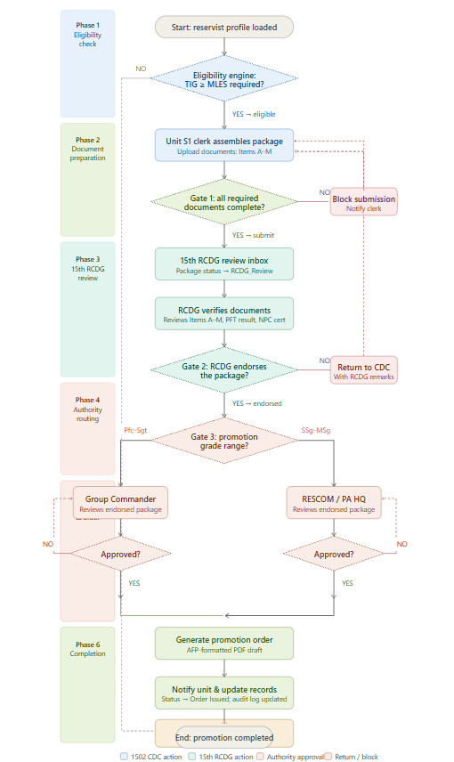

Figure 8. Promotion Package Routing Workflow

Dashboard and Analytics Module
The Dashboard and Analytics Module provide a centralized monitoring interface that enables authorized users to track the progress of promotion packages across all participating units and organizational levels. The dashboard presents real-time summary statistics, including the total number of eligible reservists, overdue promotions, pending promotion packages, and approved promotions. These metrics are automatically updated whenever promotion records, document submissions, or workflow statuses change within the system.
The module also supports promotion backlog analysis by generating summary reports that can be filtered according to unit assignment, enlisted grade, educational track, and current promotion status. This functionality enables commanders and administrative personnel to identify delayed promotions, monitor processing efficiency, and prioritize pending promotion actions. The generated reports may be exported as PDF documents for submission and record-keeping purposes.
To ensure information security and operational relevance, the dashboard implements role-based access control. Unit S1 Clerks are provided with monitoring tools limited to their assigned unit, including reservist profiles, eligibility status, and document submission progress. CDC Administrators have access to consolidated promotion statistics and submission monitoring across all supported units. The 15th RCDG reviewers are presented with endorsement queues, document verification status, and workflow routing information, while Commanders are provided with executive-level dashboards highlighting promotion backlogs, approval queues, and organization-wide promotion statistics to support timely decision-making.

Data Dictionary
Table 5 presents the primary data entities and their key attributes in the PromoTrack AFP-RF database.
Entity | Attribute | Data Type | Description
Reservist | reservist_id | INT (PK) | Unique system identifier
Reservist | full_name | VARCHAR(150) | Full name of the reservist
Reservist | enlisted_grade | ENUM(E1–E8) | Current enlisted grade
Reservist | educational_track | ENUM | General / 1st Year College / ROTC Prof
Reservist | date_of_enlistment | DATE | Date of entry into the Reserve Force
Reservist | date_of_last_promotion | DATE | Date of most recent promotion order
Reservist | unit_id | INT (FK) | Foreign key to Unit table
Reservist | is_rotc_professional | BOOLEAN | ROTC Professional qualifier flag
Promotion_Package | package_id | INT (PK) | Unique package identifier
Promotion_Package | reservist_id | INT (FK) | Linked reservist
Promotion_Package | status | ENUM | Draft / Submitted / RCDG_Review / RCDG_Endorsed / RCDG_Returned / Approved / Order_Issued
Promotion_Package | current_routing_level | ENUM | CDC / RCDG / Group_Cdr / RESCOM_PA_HQ
RCDG_Review | review_id | INT (PK) | Unique RCDG review record
RCDG_Review | package_id | INT (FK) | Linked promotion package
RCDG_Review | rcdg_reviewer_id | INT (FK) | 15th RCDG staff user who reviewed the package
RCDG_Review | review_action | ENUM | Endorsed / Returned
RCDG_Review | review_remarks | TEXT | RCDG reviewer remarks or return reasons
RCDG_Review | endorsement_timestamp | DATETIME | Date and time of RCDG endorsement or return
RCDG_Review | forwarded_to | ENUM | Group_Cdr / RESCOM / PA_HQ — destination after endorsement
Document_Item | item_id | INT (PK) | Unique document item identifier
Document_Item | package_id | INT (FK) | Linked promotion package
Document_Item | item_code | CHAR(1) | A through M
Document_Item | status | ENUM | Uploaded / Pending / Waived
Document_Item | file_path | VARCHAR(255) | Server path to uploaded file
Audit_Log | log_id | INT (PK) | Unique log entry
Audit_Log | package_id | INT (FK) | Linked package
Audit_Log | action | VARCHAR(100) | Action performed (Submitted, RCDG Endorsed, Returned, Approved, etc.)
Audit_Log | actor_id | INT (FK) | User who performed the action
Audit_Log | actor_org | ENUM | CDC / RCDG / Group_Cdr / RESCOM_PA_HQ
Audit_Log | timestamp | DATETIME | Date and time of action
Table 5. Data Dictionary — Primary Entities

Development Tools and Technologies
Table 6 presents the technologies used in the development of PromoTrack AFP-RF.
Layer | Technology | Purpose
Front-End | HTML5 / CSS3 / Bootstrap 5 | Responsive user interface for all user roles
Front-End | JavaScript / jQuery | Client-side form validation and dynamic checklist
Back-End | PHP 8.2 / Laravel 10 | Server-side logic, eligibility engine, routing
Database | MySQL 8.0 | Relational storage of all system data
Authentication | Laravel Sanctum | Role-based access control and session management
File Storage | Local File System / AWS S3 (optional) | Secure storage of uploaded promotion documents
Report Generation | DomPDF / Laravel-PDF | PDF generation for promotion order drafts
Version Control | Git / GitHub | Source code management
Testing | PHPUnit | Unit and integration testing of eligibility engine
Deployment | Apache / Ubuntu Server | Local server deployment at 1502 CDC
Table 6. Development Technologies

System Evaluation Procedure
The system was evaluated using the ISO/IEC 25010 System Evaluation Questionnaire administered to three respondent groups following the procedure below:
- System demonstration. Respondents were given a structured demonstration of all system modules lasting approximately 45 minutes. The demonstration was divided into two parts: the 1502 CDC workflow (profile management, eligibility check, document upload, package submission) and the 15th RCDG workflow (package inbox, documentary review, endorsement, forwarding to higher headquarters).
- Guided task completion. Respondents performed role-specific representative tasks. 1502 CDC users performed: (1) searching for a reservist and viewing their eligibility status; (2) uploading a promotion document; (3) submitting a completed promotion package. 15th RCDG users performed: (4) accessing the regional review inbox; (5) reviewing a submitted package for documentary completeness; (6) endorsing a qualified promotee and generating the forwarding endorsement to the Group Commander or RESCOM / PA headquarters. All commander-level respondents performed: (7) approving a forwarded promotion package; and (8) generating the Promotion Backlog Report.
- Questionnaire administration. Respondents completed the ISO/IEC 25010 questionnaire immediately following the task completion exercise.
- Data analysis. Responses were analyzed using weighted mean and standard deviation. The following scale was used to interpret weighted mean scores: 4.21–5.00 = Outstanding; 3.41–4.20 = Very Satisfactory; 2.61–3.40 = Satisfactory; 1.81–2.60 = Unsatisfactory; 1.00–1.80 = Needs Improvement.

Quality Characteristic | Sub-characteristic | Evaluation Indicator
Functional Suitability | Functional Correctness | Eligibility computation produces correct status for all test cases in the MLES matrix
Functional Suitability | Functional Completeness | All thirteen checklist items are trackable and gateable; all routing levels (CDC → RCDG → Higher HQ) are correctly enforced
Functional Suitability | Functional Appropriateness | Report outputs and endorsement documents match AFP promotion format requirements
Usability (1502 CDC Users) | Learnability | CDC clerk can navigate core submission workflow after a single demonstration
Usability (1502 CDC Users) | Operability | Error messages are clear and guide the CDC user to corrective action
Usability (15th RCDG Users) | Learnability | 15th RCDG reviewer can access inbox, verify documents, and endorse packages after a single demonstration
Usability (15th RCDG Users) | Operability | Endorsement and forwarding interface is clear and produces the correct higher-HQ routing without manual intervention
Usability (All Users) | User Interface Aesthetics | Interface is clean, organized, and role-appropriate for military administrative context
Performance Efficiency | Time Behavior | All transactions — including RCDG review actions — complete within three seconds
Performance Efficiency | Resource Utilization | System remains responsive with fifteen concurrent users across both 1502 CDC and 15th RCDG access points
Reliability | Fault Tolerance | Session data is preserved for both CDC and RCDG users during network interruption
Reliability | Recoverability | System returns to correct state and preserves endorsement records after unexpected shutdown
Security | Confidentiality | Reservist personal data is accessible only to authorized users at each organizational level
Security | Integrity | Promotion records and RCDG endorsements cannot be modified without an audit log entry
Security | Accountability | All actions — including RCDG endorsements and forwarding decisions — are logged with actor identity, organization, and timestamp
Table 7. ISO/IEC 25010 Quality Characteristics and Evaluation Indicators

Ethical Considerations
The study observes the following ethical standards: (1) Informed consent was obtained from all respondents prior to their participation in interviews and system evaluation; (2) All reservist data used in system testing was anonymized using fictitious identifiers; (3) The study complies with Republic Act No. 10173 (Data Privacy Act of 2012) in its design of the system's data handling procedures; (4) The military classification of any information shared by 1502 CDC personnel during the requirements gathering phase was respected, and no classified AFP operational information was incorporated into the research paper; and (5) The system was developed for academic research purposes and any operational deployment requires separate AFP authorization.

References

Abad, M. F., Reyes, J. L., & Torres, G. P. (2023). Functional analysis of the Civil Service Commission's HRIS promotion module: Gaps and recommendations. Philippine Journal of Public Administration, 67(1), 45–71.
Batungbakal, R. A., & Cruz, D. M. (2024). Development and ISO/IEC 25010 evaluation of a personnel management information system for AFP non-commissioned officers. International Journal of Advanced Computer Science and Applications, 15(2), 210–225.
Bugayong, L. T., & Serrano, M. C. (2021). ISO/IEC 25010 in Philippine IT capstone research: A bibliometric review and methodological guide. Asian Journal of Information Technology, 20(4), 88–102.
Castillo, R. B., & Macaraig, S. G. (2023). Impact of a digital promotion tracking system on processing time and document return rates in a Philippine local government unit. Journal of e-Government Studies and Best Practices, 2023, Article 874521.
Cuevas, A. D., & Tolentino, F. R. (2023). Constitutional obligations and reserve force administration: Legal imperatives for digital modernization in the AFP. Philippine Law Journal, 97(2), 312–345.
Dela Cruz, M. B., Navarro, J. A., & Padua, R. T. (2024). Digital transformation outcomes in AFP administrative functions: A multi-case study. Journal of Defense Studies (Philippines), 12(1), 1–28.
Ferrer, C. L., & Ocampo, P. R. (2023). Identifying systemic promotion backlog through digital eligibility classification systems: A framework for military HR analytics. Philippine Journal of Information and Communications Technology, 9(2), 44–61.
Gomez, T. N., & Ramos, A. F. (2021). Rule-based systems versus machine learning for government eligibility determination: A comparative analysis. International Journal of Intelligent Systems, 36(8), 3890–3914.
Lim, E. C., & Aquino, B. D. (2021). Document management systems in Philippine government agencies: A systematic review of compliance enforcement mechanisms. Government Information Quarterly, 38(4), Article 101598.
Luna, P. V., & Estrada, C. J. (2023). DSDM in academic capstone projects: A guide to fixed-time agile development for information systems students. Philippine Journal of Computing and Information Sciences, 11(1), 22–39.
Mendoza, R. S., & Garcia, L. T. (2022). Three enabling conditions for IS implementation in resource-constrained Philippine government organizations. Information Technology for Development, 28(3), 512–534.
Olivarez, J. M., & Tan, F. B. (2022). Conditional document requirements in Philippine government workflows: Sources of submission error and digital remediation strategies. Electronic Government: An International Journal, 18(2), 145–168.
Padilla, C. A., & Santos, R. M. (2021). Digital HR systems in the AFP: Coverage gaps in the reserve component and pathways to provincial digitalization. Philippine Defense Review, 3(2), 89–114.
Ramos, D. F., & Villanueva, P. Q. (2023). Meta-analysis of ISO/IEC 25010 evaluations of Philippine government information systems: Patterns in quality scores and design implications. Journal of Systems and Software, 198, Article 111600.
Republic Act No. 7077. (1991). Citizen Armed Forces of the Philippines Reservist Act. Republic of the Philippines.
Republic Act No. 10173. (2012). Data Privacy Act of 2012. Republic of the Philippines.
Reyes, J. F., & Fernandez, A. L. (2024). Administrative delays in AFP Reserve Force enlisted promotion: A document analysis of 1502 CDC records in Agusan del Sur. Journal of Military Studies (Philippines), 6(1), 33–57.
Richey, R. C., & Klein, J. D. (2022). Design and development research: Methods, strategies, and issues (2nd ed.). Routledge.
Santos, N. D., & Reyes, C. M. (2023). Digital administrative systems and promotion management in Philippine defense organizations: A literature synthesis. Philippine E-Journal for Applied Research and Development, 13(1), 1–19.
Soriano, A. B., & Navarro, L. G. (2024). Functional purity in government IS eligibility engines: Design principles for audit-compliant rule-based computation. International Journal of Information Systems in the Service Sector, 16(1), 1–18.
Tran, H. V., & Lee, J. K. (2022). Reserve force management systems in ASEAN militaries: A comparative analysis of promotion administration digitalization. Defence and Peace Economics, 33(5), 567–591.
Villanueva, M. A., & Bautista, R. C. (2022). Command authority and promotion in the AFP Reserve Force: Legal and administrative dimensions of RA 7077 implementation. Journal of Philippine Administrative Law, 14(1), 78–105.

